Daniel Williamson

Project #2

2/15/17

EE 222

Project Overview

Purpose:

The purpose of this project was to ask the user for an array size. Once we have the size of the array we prompt the user for what values you to place in the array. Depending on the size they specify is the same amount we ask for. After we have the array size and its values we go ahead and use bubble sort to sort the given array. We needed to create three functions: one to prompt the user and create the array, one to print out the array and one to do the sorting. These functions will then be called in the main function.

Approach:

To begin, I knew because it was a requirement, I had to create a global array. We only need one array, because bubble sort doesn’t require a temporary/buffer array to store values, it just changes their indices. Once we have our global array, we need to populate it. We create our function to ask for the size of the array and its values. Now in order to know that I was doing this correct, I then built the function to print out the now unordered array. Which my code was working because it was printing it out correctly. Since I had a now populated array I needed to sort it. So it was time to create my bubble sort, which I just used to algorithm the professor provided. And lastly used my print function again to print out the now sorted array.

Results:

This is a photo of the program functioning:

I wanted to create an array of size 5, I then populate it with values [91, 2, 83, 45, 2].

We then sort it and print it out!

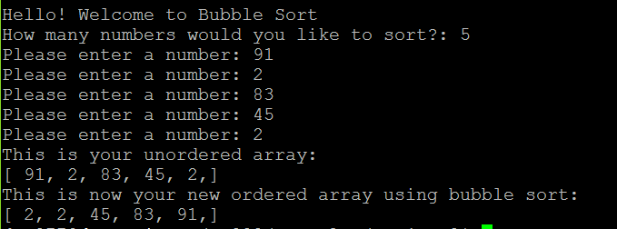

This is a photo of the program not liking the input of greater than 100 or less than 2:

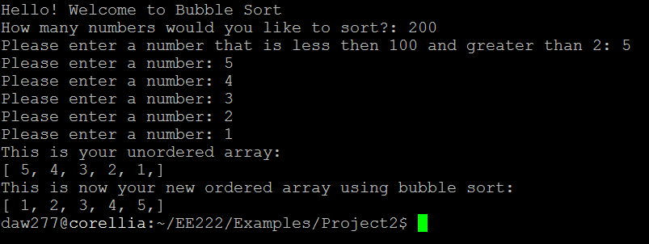

Conclusion:

In conclusion, this was a rather easy lab. I did not have very many difficulties. The only problem I ran into was I did not properly read the instructions correctly and just printed out the array in the main function. So I obviously had to change that. Which did make the code much more clean.